Title of article (max. 100 characters)

Sub-title (optional, max. 80 characters)

Family name and first name of the 1st author¹, Family name and first name of the 2ndauthor², …
¹ 1stAuthor’s affiliations (Job title, workplace, headquarter of workplace), 1stauthor’s e-mail address
² 2ndAuthor’s affiliations (Job title, workplace, headquarter of workplace), 2ndauthor’s e-mailaddress
……
…….
Abstract— A summary containing at least 350 and maximum 1800 characters, that outlines the relevancy of the topic of the article, briefly discusses the methodological solutions, delineate the results achieved including conclusions. Font type: boldface Times New Roman, font size: 9.

Index Terms: At least 3 English keywords, separated by commas.

1. Title of subsectionwith font type 10-point Verdana
The body text should be printed with font type 7.5 Verdana, justified and 0.5 cm tab should be used in the first line. There is a possibility for highlighting using boldfaced letters, printing Latin names in italics and inserting Internet references as well. The usage of foot-notes should be avoided.
References in the body text should be indicated within the pertinent sentence in the following format: (Nagy et al. 2014).
Spreadsheets, diagrams, images should be suppliedwithnumberedcaptionsplacedunderneaththemasappearingbelow:
I.A.1 | I.A.2 | I.B. | I.C.
83 | 645 | 647 | 47457
2366 | 5436 | 643364 | 68
Spreadsheet 1. The short explanation of the spreadsheet.

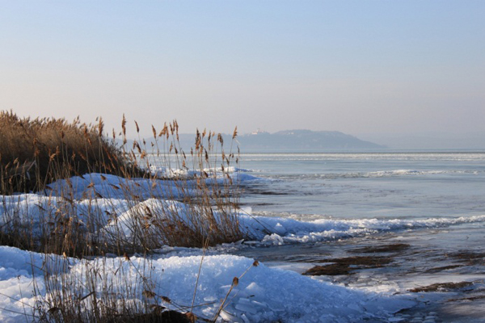
Figure 1. The short explanation of the diagram. If the length of the text of thecapture of spreadsheets, diagrams, images does not exceed 2 lines, they should be centered. If they consist of 3 or more lines, justification should be applied.

Spread sheets, diagrams and images should be referenced in the body text suchas (Spread sheet 1.) or with the explanation text: „The measurement data are contained in Spreadsheet 1.”
In the case of inserted photos, diagrams, spreadsheets attention should be payed, that their width does not exceed 8,7 cm, they are centered and that „the first line indentation (tab)” does not apply to them.
It is recommended, that the articlewill be broken up into numbered sections with the following chapter titles: introduction, review of former or current research, methodology, results, summary, acknowledgement, references.

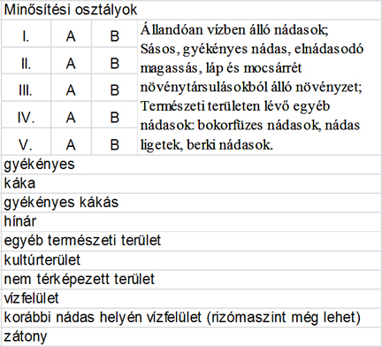
Figure 2.Spreadsheets, diagrams can also be inserted as image files, but they may not contain crabbed or unreadable texts.

The extent of the article should be less than 9500 words.

Acknowledgement

The length of acknowledgement may not exceed 1000 characters, in which the names of the institutions maynot be abbreviated, and no bold facedfonts, italics or any other highlighting can be used.

References

Bookreferences:
Grum F. and Becherer R.J. (1979): Optical Radiation Measurements. Volume 1: Radiometry, by. Academic Press, New York, 335 pp.

Articlereferences:
Lellei-Kovács E. (2011): Soil respiration responses to temperature and moisture changes in a sandy forest-steppe, 2003-2008. INCREASE workshop, 24 May 2011. Bangor, UK.
Lellei-Kovács E., Kovacs-Láng E., Botta-Dukát Z., Kalapos T., Emmett B., Beier C. (2011): Thresholds and interactive effects of soil moisture on the temperature response of soil respiration. European Journal of Soil Biology 47, 247-255.

Pomogyi P. (2010): Nádasminősítés – nádgazdálkodás-tervezés összefüggései a Balatonon, Kis-Balatonon és a Velencei-tavon. A Magyar Hidrológiai Társaság által rendezett XXVIII. Országos Vándorgyűlés dolgozatai. ISBN 978-963-8172-25-9.http://www.hidrologia.hu/vandorgyules/28/index.html

Declaration: the submitted manuscript is the indicated authors’ own work, and the authors of all other pieces of information, diagrams and other texts everywhere in the article have also been duly referenced. This article have not been published in other journals. All authors, contributors and supporter of the submitted article agree with the publication in the Journal of Remote Sensing Technologies and GIS. The manuscript does not contain false information. The authors are aware, that there is no incompatibilities, and any inhibitory factors regarding the processing, the proofreading and the publication of the manuscript, furthermore they agree, that they will be included in the authors photographic on-line RS&GIS database.

© 2015 by the authors; licensee RS&GIS, Hungary.

This article is an open access article distributed under the terms and conditions of the Creative Commons Attribution license

(http://creativecommons.org/licenses/by/4.0/).

